

**Lab No:** 15  **Date:** 2082/

**Title:** **Prepare a lab report to create and terminate process.**

When working with Linux, one of the core concepts to understand is the idea of a process. A process represents any program that is currently running on the system, whether it’s a simple background task or a complex application. Each process is uniquely identified by a Process ID (PID), which allows users to monitor, manage, and control it. New processes can be created by executing commands like sleep, and unnecessary ones can be terminated using their PID. These basic operations form the foundation of process management in Linux and are essential for efficient system usage.

### **Step-by-Step Theory:**

**1.** sleep 1000 & **— Create Process**

* sleep 1000 tells Linux to pause for 1000 seconds
* & runs the command in the background
* This creates a new background process
* A PID (process ID) is assigned to it

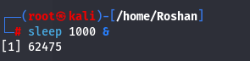

**2.** ps aux | grep sleep **— View Process**

* ps aux lists all running processes
* | grep sleep filters the list to show only lines containing "sleep"
* This may also show the grep command itself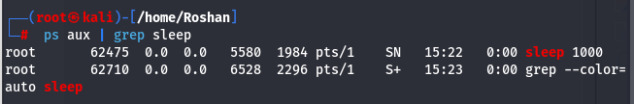

**3.** pgrep sleep **— Get Sleep PID Only**

* pgrep searches for process names
* pgrep sleep returns only the PID of the sleep process
* Safer and cleaner than using grep  
  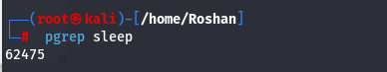

**4.** kill <PID> **— Terminate the Process**

* Sends the SIGTERM signal to the given PID
* This politely asks the process to stop
* Preferred method for ending a process

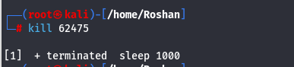

**Conclusion**

Linux offers robust commands for effective process management. You can easily start processes with basic commands such as sleep, track their status using tools like ps and pgrep, and stop them with kill. Gaining familiarity with these fundamental commands allows you to manage system resources better and maintain control over active programs.